Scaling offline business or where to place a new shop/bar/something else

IBM Applied Data Science Capstone Project report

by: Ivan Ilukhin

"Sydney" by nnic is licensed under CC BY-NC-SA 2.0

Introduction

Many businesses very often face the next problem: when it begins to grow up, owners start to think about: where to open new outlets or found another place where you satisfy your customers' needs. This issue usually relates to offline companies like barbershops, veterinary clinics, retail stores, etc. There is a lot of parameters that impact on the decision: monthly rent, competitors, crime rates, a wealth of the people around and many others. This little research is focusing on the similarity of the boroughs or How to split all districts into groups.

The idea is based on the underlying assumption that we should found spots in similar places.

Business Problem

The objective of this research is to find similar districts and extract attributes that distinguish them. I selected the Greater Sydney Area for the region of study. It's one of the biggest agglomerations in the world, consists of almost about 650 suburbs that sprawl about 70 km to the west, 40 km to the north, and 60 to the south and generates approximately 24.1% of Australia's GDP.

Target audience of this project

The result of this project will be interesting, primarily, for the business owners and people who choose the location for expanding. It may also be of interest to investors, especially when you are presenting your startup or when you ask for money to grow your business.

Data

For classifying suburbs, we should get features for each district. In this research, I will use the next:
- latitude and longitude to show them on a map;
- venue data, amount of each type of venues;
- crime data, about of crimes grouped by type(murder, robbery, carjacking;
- distance from the Sydney Central Business District (CBD).

Data sources
List of the suburbs will be obtained from the relevant wiki page - https://en.wikipedia.org/wiki/List_of_Sydney_suburbs
Crime data are available as csv table where stored crimes count from 1995 to 2019 splitted by month for all New South Wales suburbs. Available there.
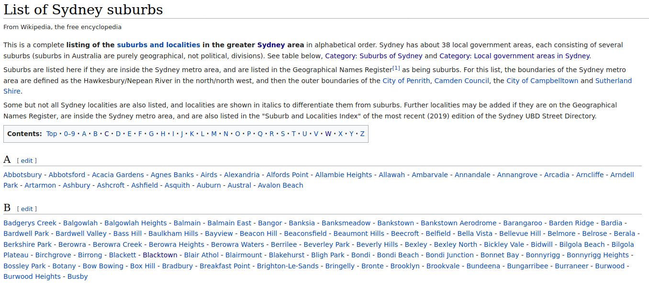Wiki page with Sydney's suburbs
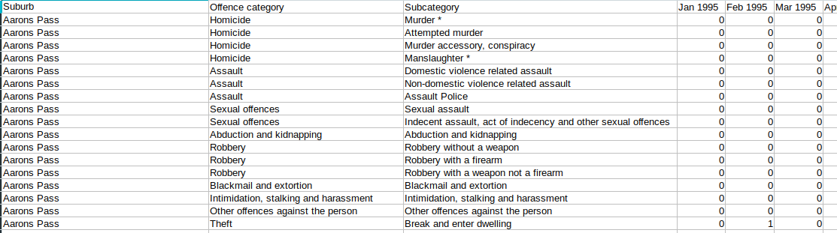Crimes table
Coordinates of suburbs will be obtaned from the the Google Maps Geocoder API. We should make request with a subirb’s name and the country.
Distance from Centrall Busines District will be calculated by applying distanse method from the geopy package on the previously getted coordinates.

Data cleaning and visualization
Let’s transform the all above sources into datasets.
- Suburbs names from the wiki page
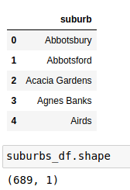

2. Then get the locations using the Google Maps Geocoder API
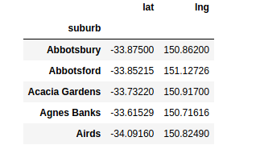Suburbs with latitudes and longitudes
And show all suburbs on the map.
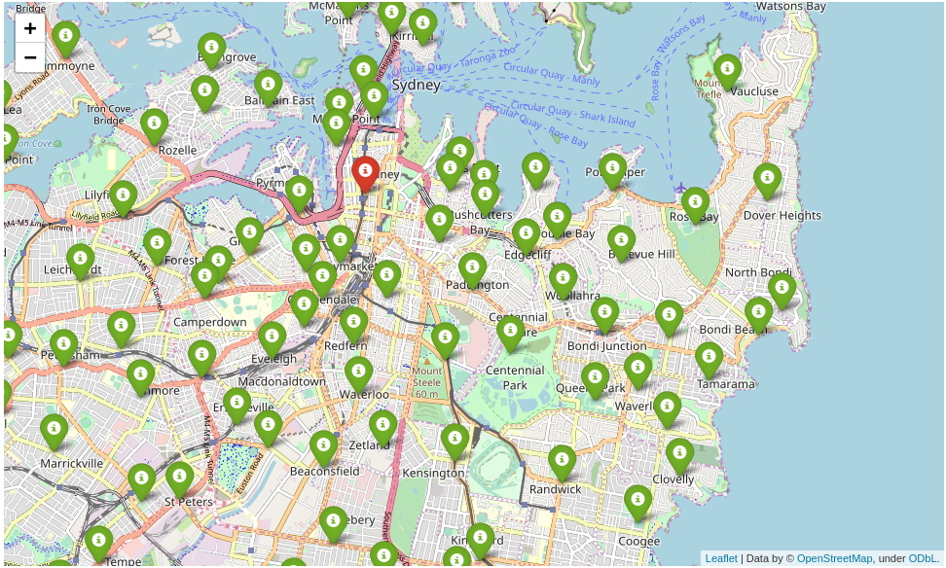The center of Sydney. Red mark is Cenral Business District.
On this map we see the outliner and immediately delete it.
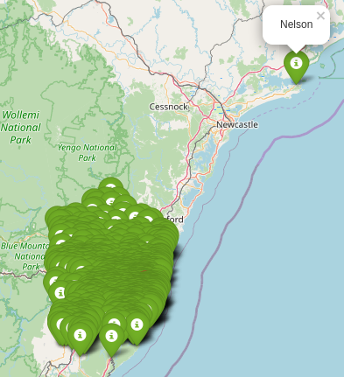All suburbs

3. Crude distance from the central district will be calculated based on the centres of suburbs, got on the second step.

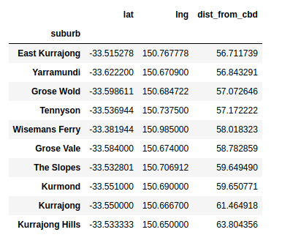Farest from the CBD districts after removing the outliner
4. Monthly crime reports based on the data from the Bureau of Crime Statistics and Research.

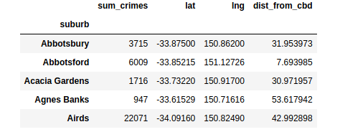Suburbs with coodinates, distanse and summary amount of crimes
5. And the list of venues using Foursquare API in 800 meters radius. This dataset contains suburbs with at least one venue.
6. Also add total venues to the total dataset
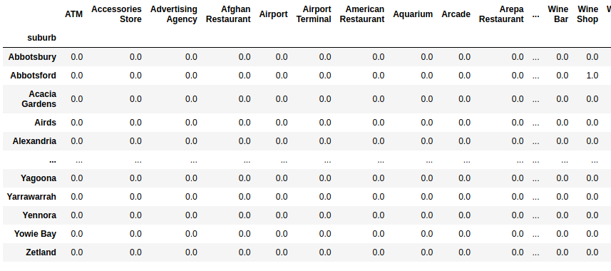Venues count dataframe
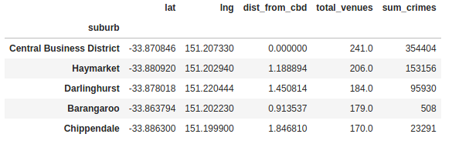Total dataframe
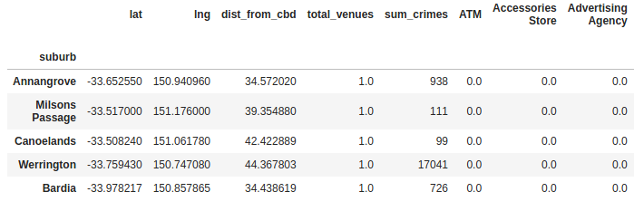
7. And finally let’s create combined dataframe

Methodology

Finding correlations
Main goal of this research is to find the best place for the certain kind of business. For it we will use Correlation Analysis. Pandas provides fantastic method corr for it that computes pairwise correlation of columns. I will use Pearson corellation coefficient to compare it.
First we should normalize our venues dataset – transform amount of venues of the certain type: leave zero values and remove all non zero values to 1.
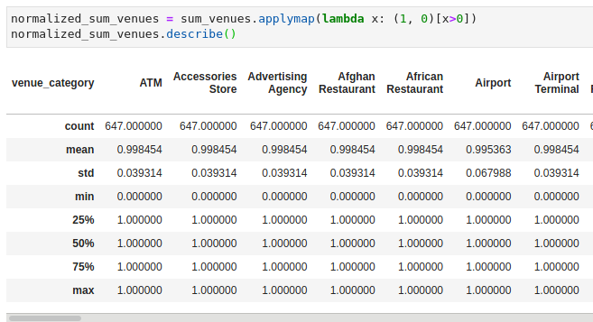
c

also normalize and remove not using features from suburbs_total_df dataset.
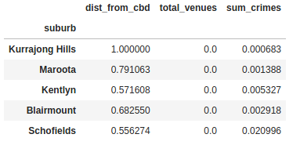
And merge them and build corellation matrix
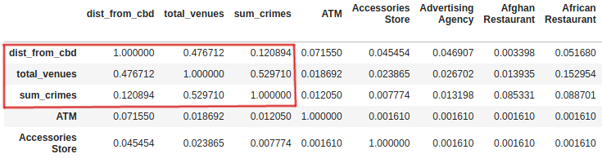Fragment of the corellation dataframe
Let's take a look at the selection. We can see that amount of crimes doesn’t depend on distance from the city center but depends from the total venues. This is fairly obvious: more places →more people density →more crimes.
If the Pearson correlation coefficient is between 0.5 and 1.0 it is said to be a strong correlation, so let’s drop all values smaller than 0.5 and plot a heatmap.
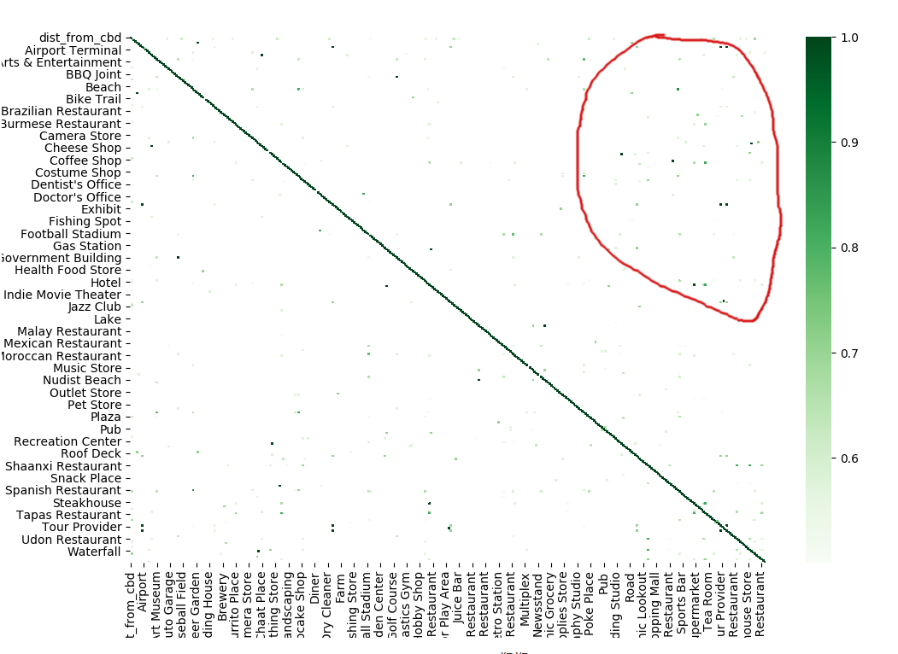Heatmap for all corellations > .5

Selected area shows that there is not too much but high enough corellation between venues. Convert the matrix to a more convenient structure
At this table we see what venues usually placed closer to the venue from the category_x. It’s looks pretty obvious that near aquarium we can find some places for children like a candy store or a zoo.
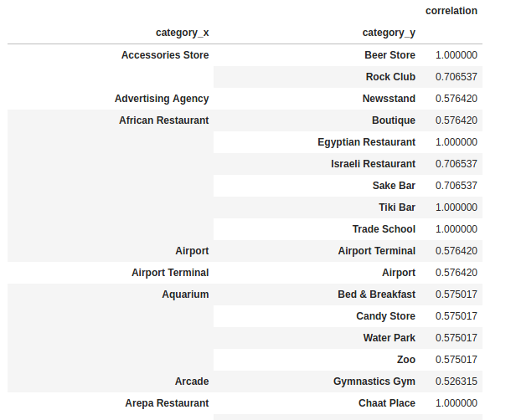Transformed dataframe

Results
Applied Pearson correlation to our datasets we’ve got the following result.
There is a correlation between the type of the venue and other venues that are placed nearby, so we can choose the suburb for new business based on how many correlated places in the suburb.
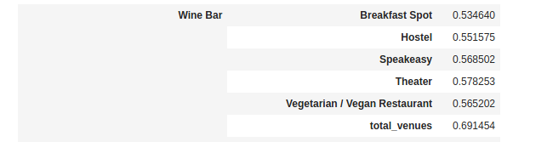
For example you want to open a new Wine Bar. Let’s look at these related venues.
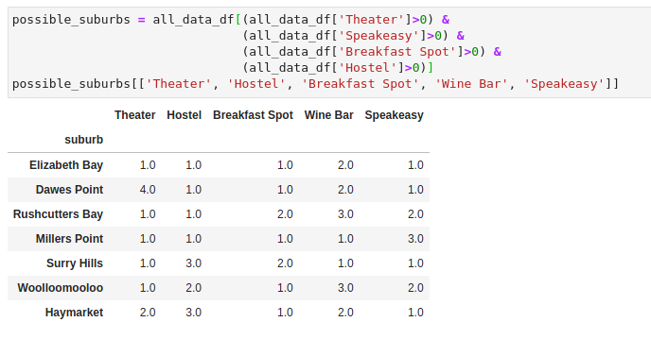
We see that usually in this suburb placed Hostels, Theaters, Breakfast Spots, Speakeasy and Vegan Restaurants. Also it depends on total_venues, that’s mean that we should place it in a popular/touristic district, where are a lot of venues.
We found the 7 suburbs, but unfortunately they all already have wine bars. Let's remove two of them type of venue from it. Speakeasy and Hostel for example.
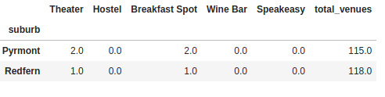

We found the two free from Wine bars suburbs. Total venues are almost the same so we can open a new bar in both.

Discussion
For further improvements, we can add census data for each suburb because many parameters depend on it. Age and mean suburb wealth are essential parameters that can strongly persuade on the decision. Also, we didn't count how long the analysed venues exist to except recently created businesses.
Venues types absolutely don't depend on a crime rate in the suburbs, but the amount of crimes depends on the venues count.

Conclusion

In this research were showed how to find a new place for your business using the correlation analysis.
Even the simplest method can solve your problem, not only huge neural networks and combinations of complex ML-algorithms, just Pearson correlation, map and scatterplot charts.

